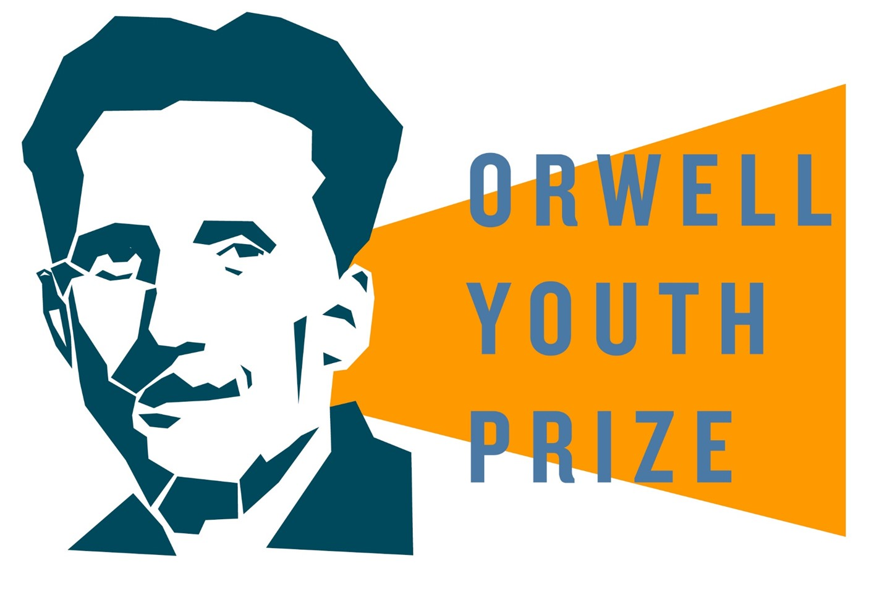
THE ORWELL YOUTH PRIZE 2026/27
Acts of Courage

1. Starter 5 minutes
In pairs or small groups, discuss: describe a moment when you did something that took courage.
- What made you do it?
- Were you afraid of anything?
- Looking back, does it still look brave?

2. Three ways of thinking about courage 15–20 minutes
Orwell wrote about courage from several different positions in his life: as a colonial policeman in Burma, as a volunteer fighting fascism in Spain, and as a novelist imagining a world where independent thought itself became dangerous. In groups, read each quote below and discuss the question underneath it.
Courage and Conformity
‘There was truth and there was untruth, and if you clung to the truth even against the whole world, you were not mad.’ Nineteen Eighty-Four
Discuss: When might staying quiet be brave, and when is it just the easiest option?

Courage and Fear
‘He wears a mask, and his face grows to fit it.’ Shooting an Elephant
In this essay, Orwell is called upon, whilst working as a police officer in Burma, to shoot an aggressive elephant. He doesn’t want to do it but goes ahead because the local crowd expects it of him and he’s worried about being ridiculed.
Discuss: Is it possible to do something that looks brave for a cowardly reason?

Courage and Ordinary Life
‘If there is hope, it lies in the proles.’ Nineteen Eighty-Four
Discuss: Whose courage tends to go unnoticed or unrewarded?

3. Crafting your entry 10 minutes
Your task is to show courage without ever stating it outright. Try a few of these:
- Begin with a moment of fear or hesitation, something you've seen, felt, or imagined.
- Use characters, setting, or voice to express your take on courage without directly stating it.
- Think about contradictions: when courage looks like fear from the outside, or when someone is brave in one moment and not the next.
- Use sensory detail and rhythm to make your writing vivid and alive.
Choose a form: essay, short story, poem, script, letter, diary entry, or something in between.
Jot your first idea below:

4. Six things to consider
Keep these in mind as you write and redraft:
- Political purpose: give your writing a clear message or aim
- Clarity of expression: make your ideas easy to understand, avoid jargon
- Brave and independent thinking: be honest about what you really believe
- Open and informed thinking: check your own views against good information
- Artful writing: use language that sounds and feels good to read
- Alignment to the theme: show how your writing explores courage

5. Warm-up: stream of consciousness 5 minutes
Write whatever comes into your head on the theme of courage. Don't stop, don't correct yourself, just keep writing. When the 5 minutes are up, read it back: what stands out?

6. Start your first draft remaining lesson time
Use what you've gathered in Steps 1–5 to begin writing. You can work individually or with the person next to you.

